Laboratory 04

Jeffrey Daniel Leiva Cascante
Tamara Nicole Rodríguez Luna
Computer engineering department, Tecnológico de Costa Rica
IC4301 – Databases I
Teacher: Msc. Adriana Álvarez Figueroa.
September 26th 2022.

In this document are the evidence of laboratory 04 where you can see the objects
created, data inserted, modified, among others.
Evidence:
- The point one is in the folder `Point 1` in the laboratory 04 zip.
- The point two is in a folder `Point 2` in the laboratory 04 zip.
- The point three is in a folder `Point 3` in the laboratory 04 zip, and there is a folder called in the middle of the points and in it are the tables created for both the entities, data insertion and others.
- The point 4 by standard is created in all fields that will need the CONSTRAIN and is found in most of the fields in the tables that merit it
- 5. Develop the following functions, procedures or packages according to Corresponds, queries were made in a descending manner starting from d when the photographs were taken, therefore in the console the data that was printed is decremented:
- getName from studentcard:
- Here is an image of table student before the query:
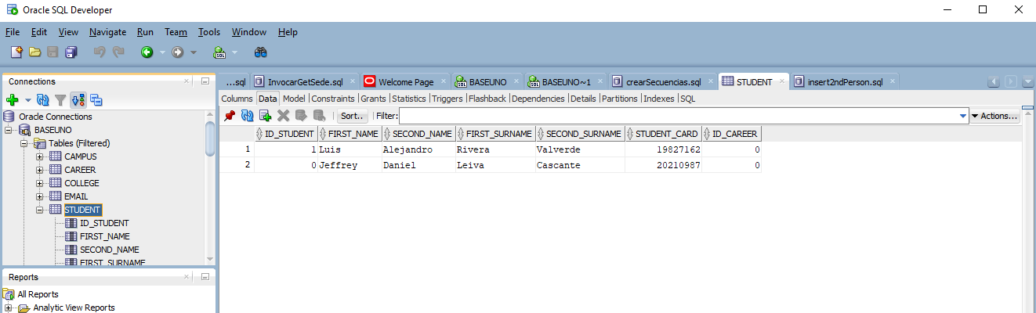
- Here is an image with the query:
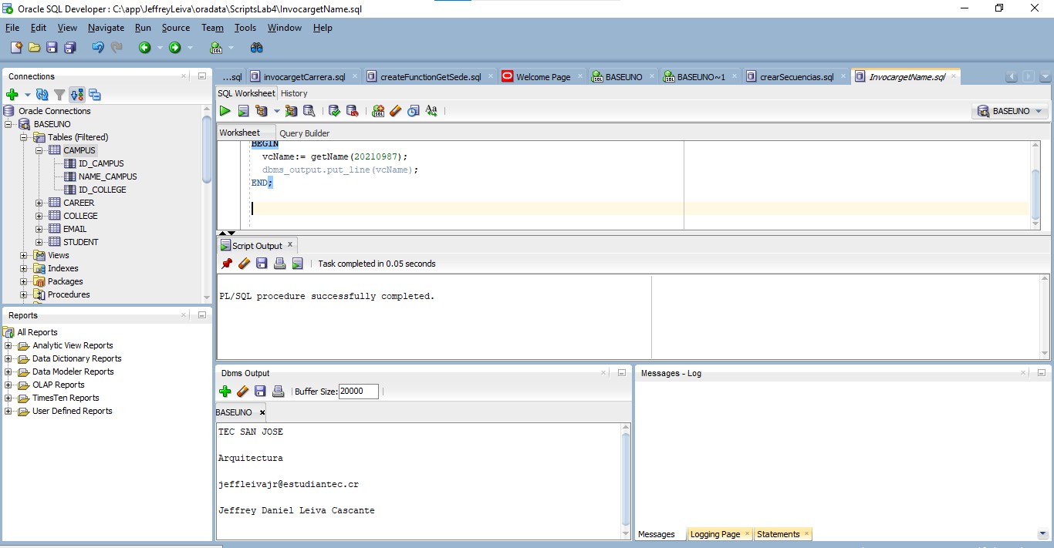
- getEmail from id_student:
- Here is an image of table mail before the query:
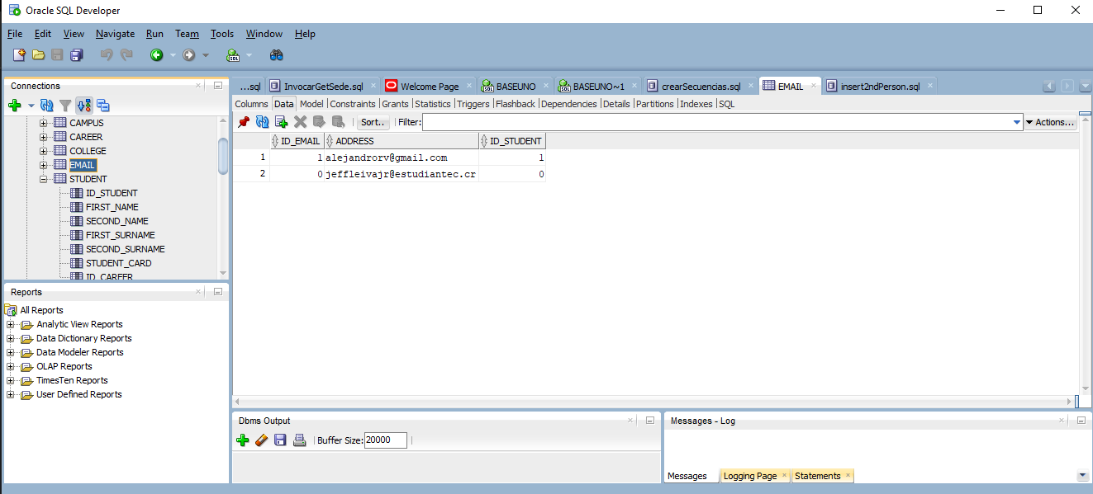
- Here is an image with the query:
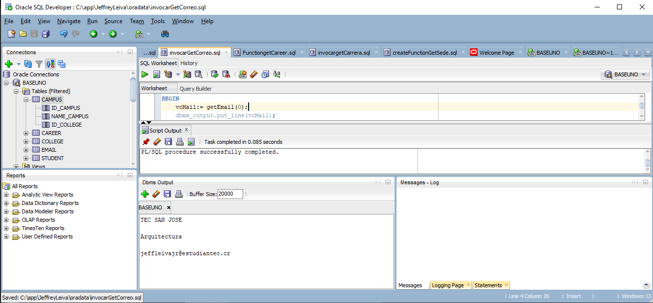
- getCareer from the id_student, scilicet, the career to which belongs the student:
- Here is an image of table Career before the query:
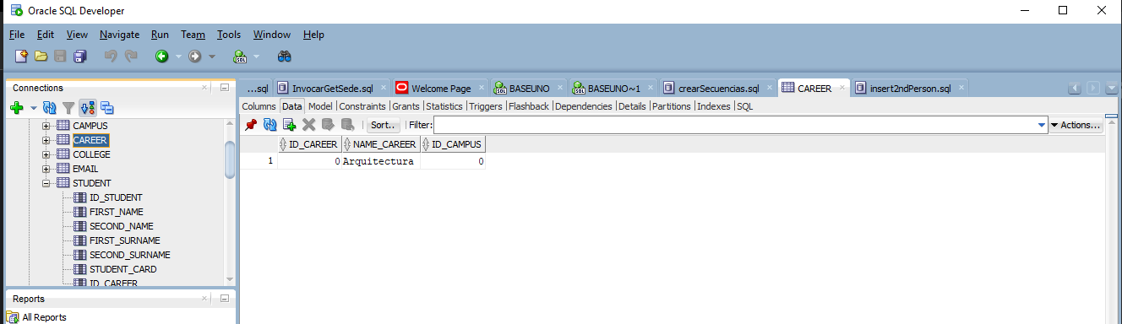
- Here is an image with the query:
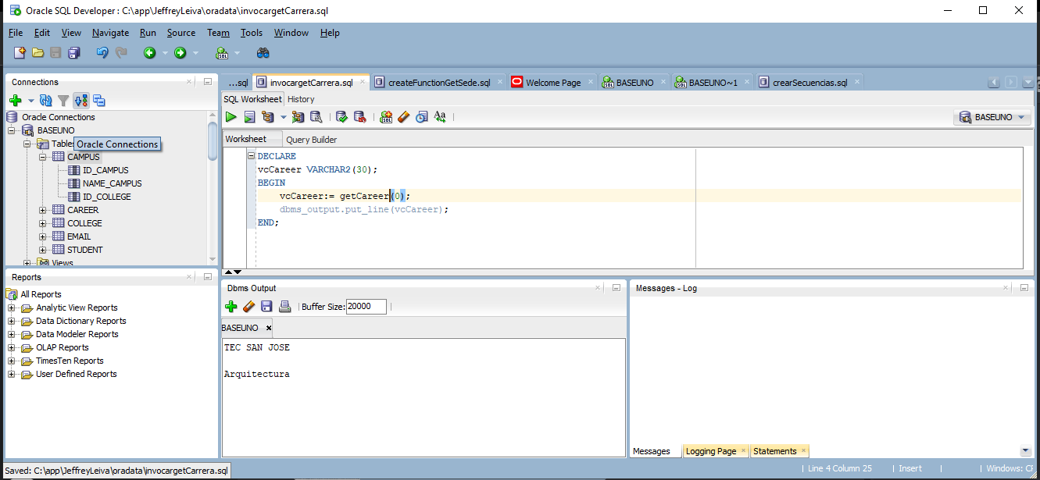
- getCampus from id_student:
- Here is an image of table Campus before the query:
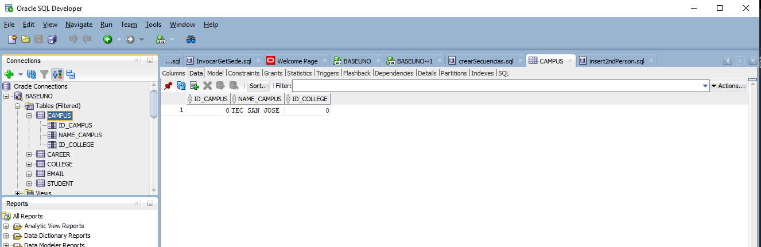
- Here is an image with the query:
